**Calculate Trip Cost**

CalculateTripCost_ Hackathon zipped file contains the following folder:

1. CalculateTripCost

CalculateTripCost contains the following folders:

1. Drivers folder contains the Chrome driver, Firefoxdriver and Operadriver.
2. SRC folder contains the following packages::
   1. Main/java
      1. DriverSetup
      2. GetHotelDetails
      3. Languages
      4. LaunchedYear
      5. PassengersAndCrew
      6. ReadCruiseDetailsExcel
      7. ReadUserDetailsExcel
      8. SearchDestination
      9. SetCruiseDetails
      10. SetDates
      11. WriteCruiseDetails
      12. WriteHotelDetails
   2. Test/java
      1. ExtentReport
      2. Testng_CalculateTripCost
   3. Excel_Input (Excel Input)
   4. Excel_Output (Excel output)
   5. Error_Screenshots
   6. Pom.xml
   7. testng.xml
   8. CruiseTestNG.xml
   9. HotelTestNG.xml
   10. HTML_Report (Extended Report)
   11. Test-output
   12. Target
   13. Documentation folder
   14. Presentation folder

# MAVEN Implementation:

Console Output after Maven Implementation(BUILD SUCCESS)

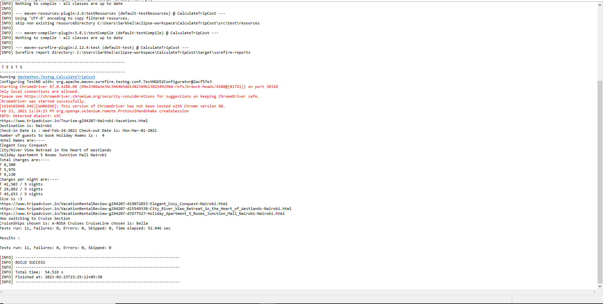

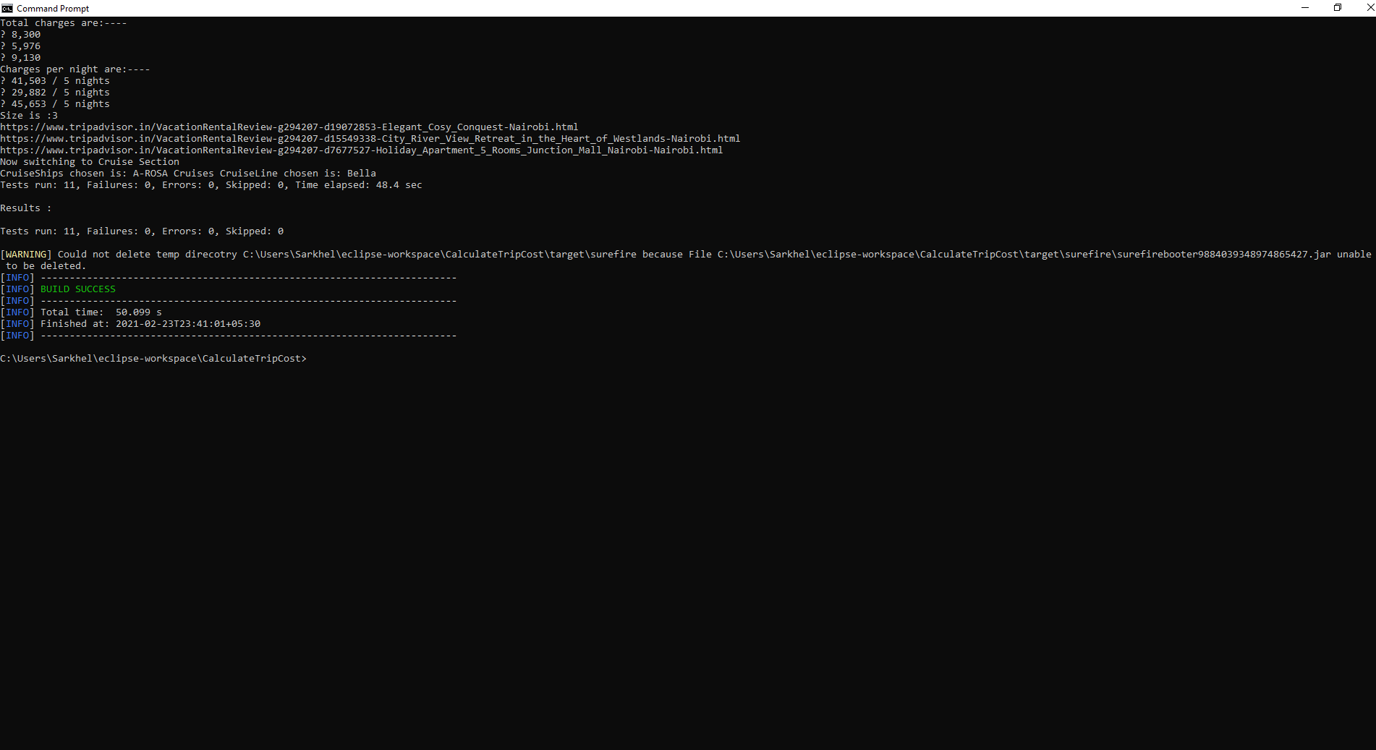

# Test Report:

# 

**JENKINS Implementation:**

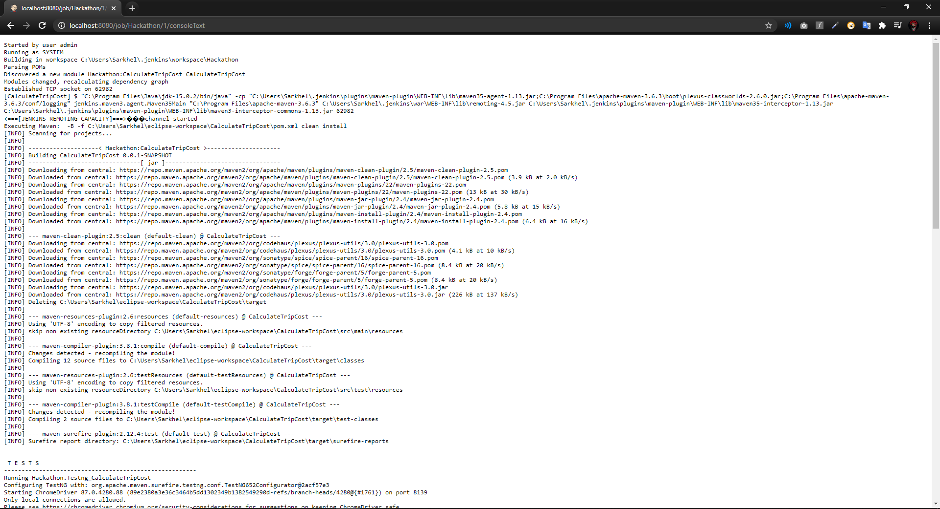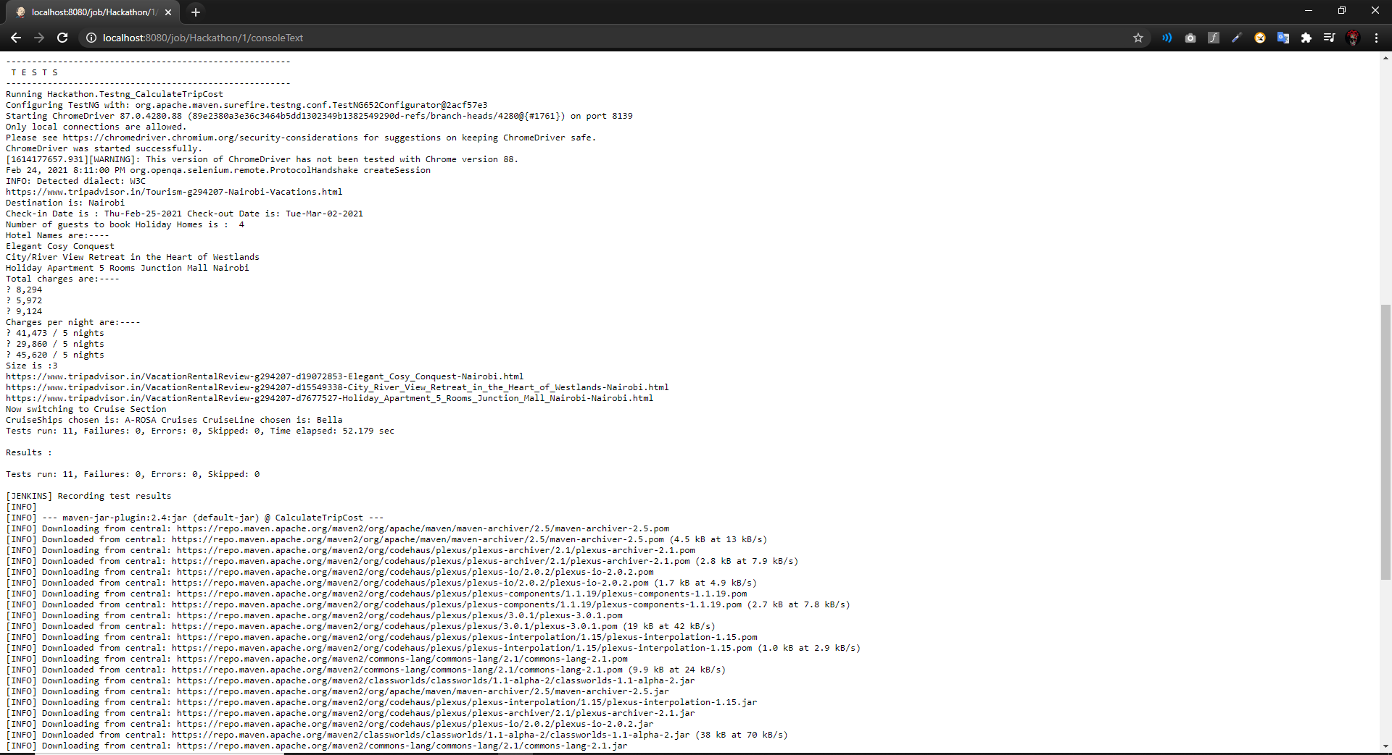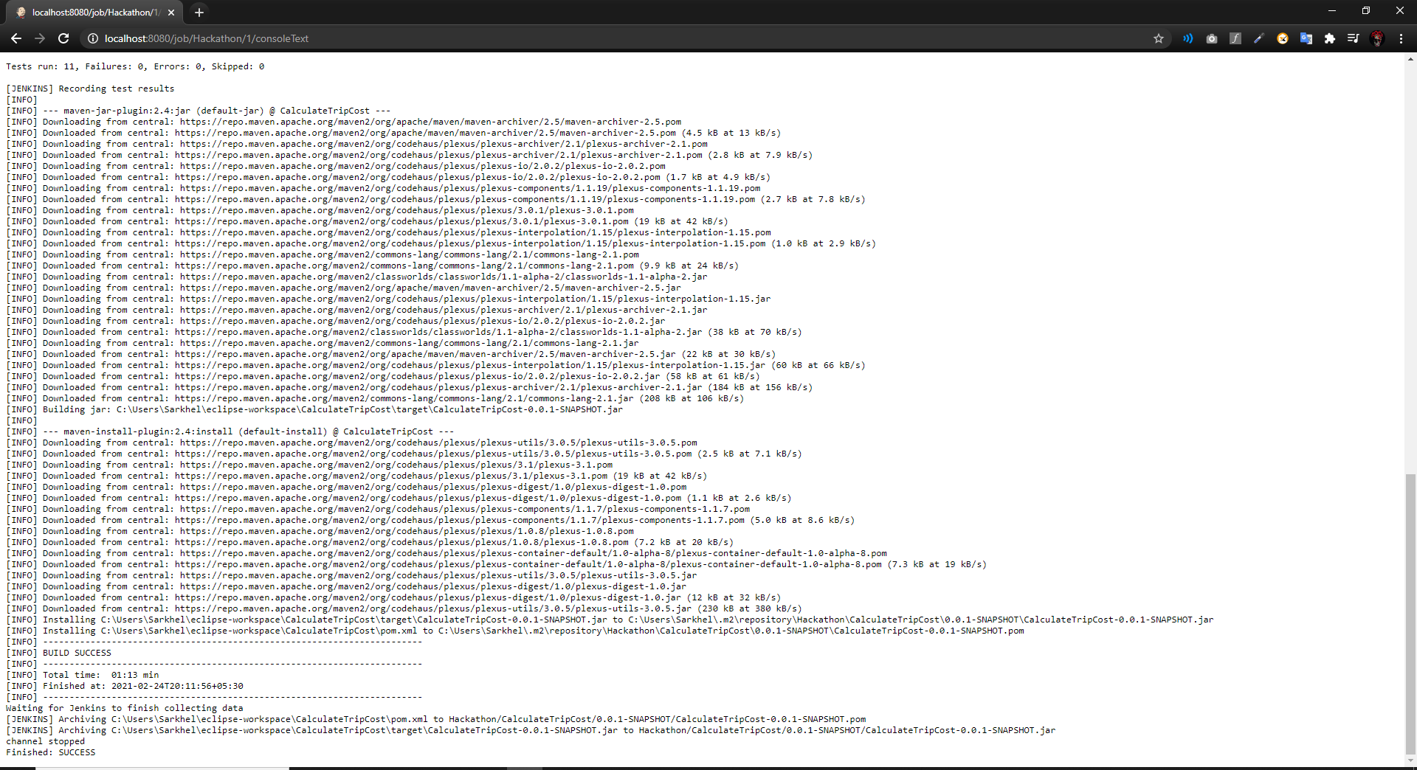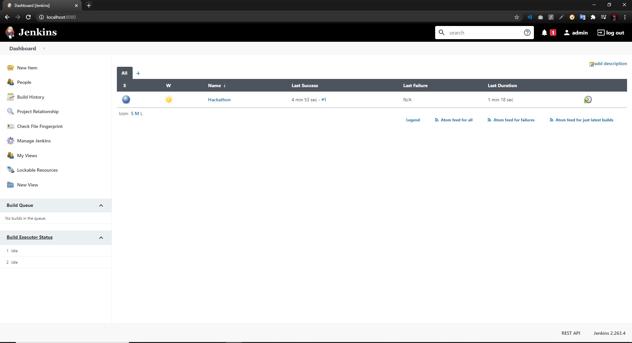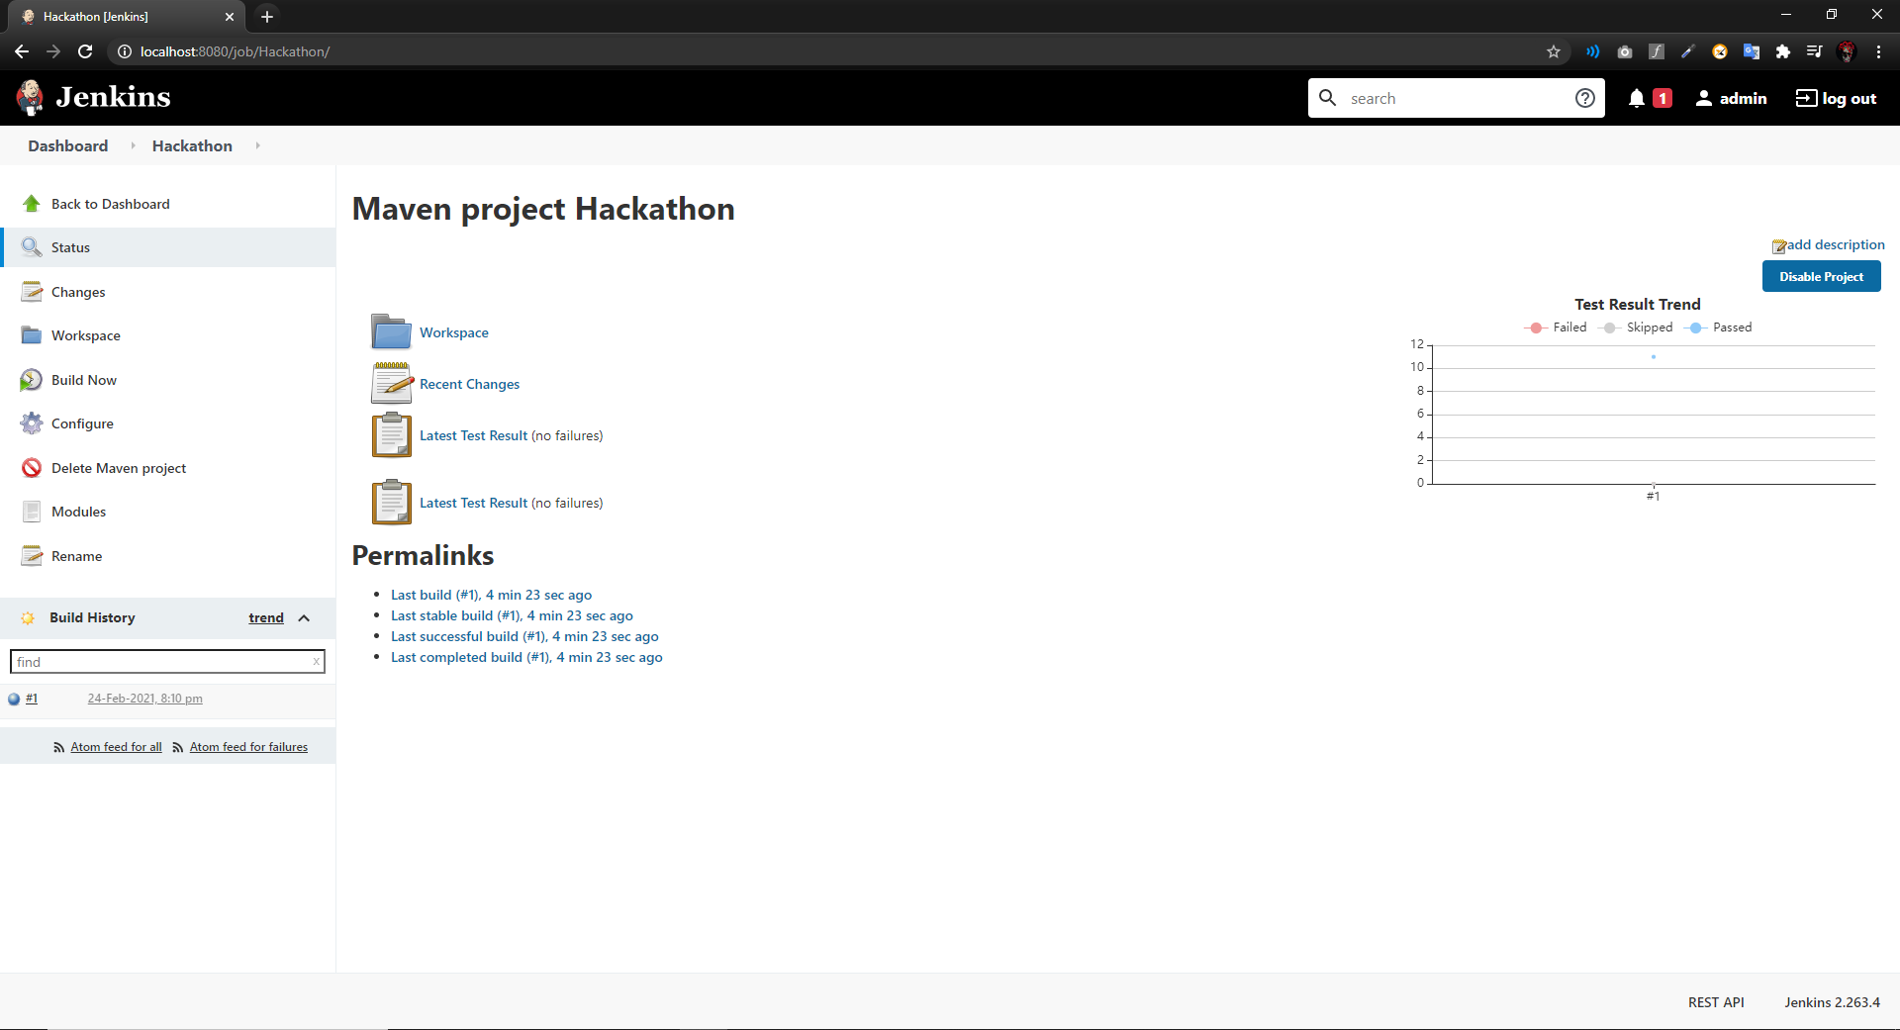

**Selenium Grid Implementation:**

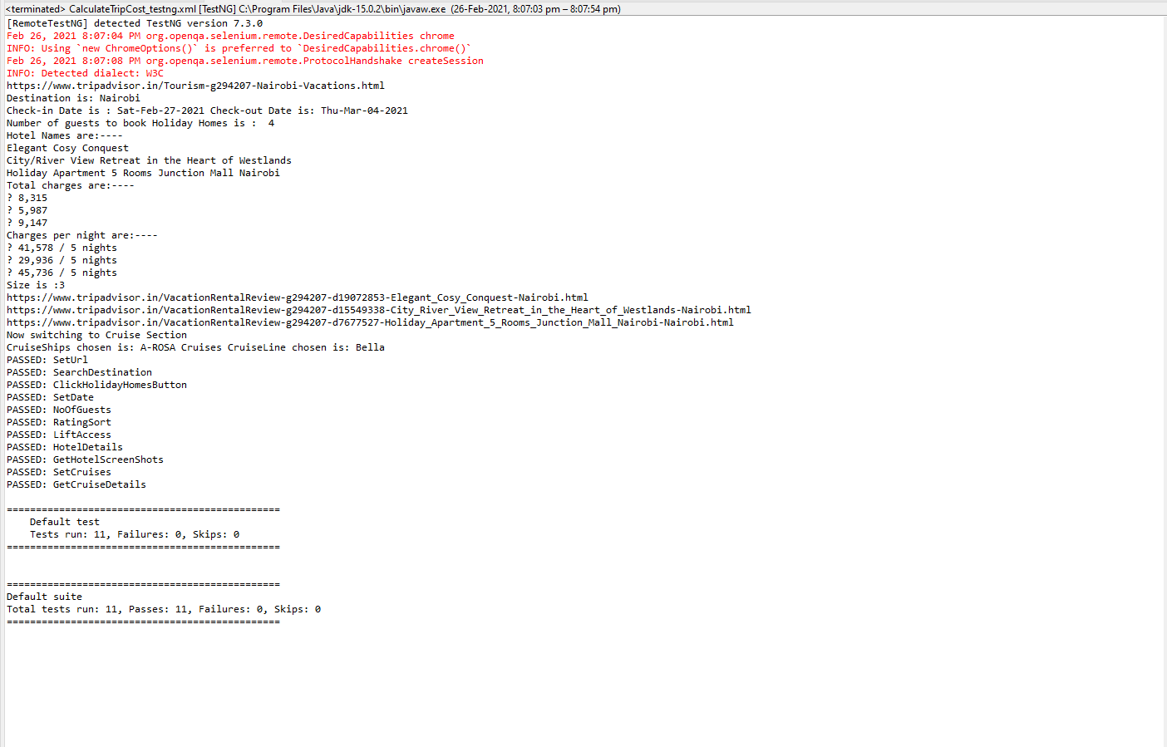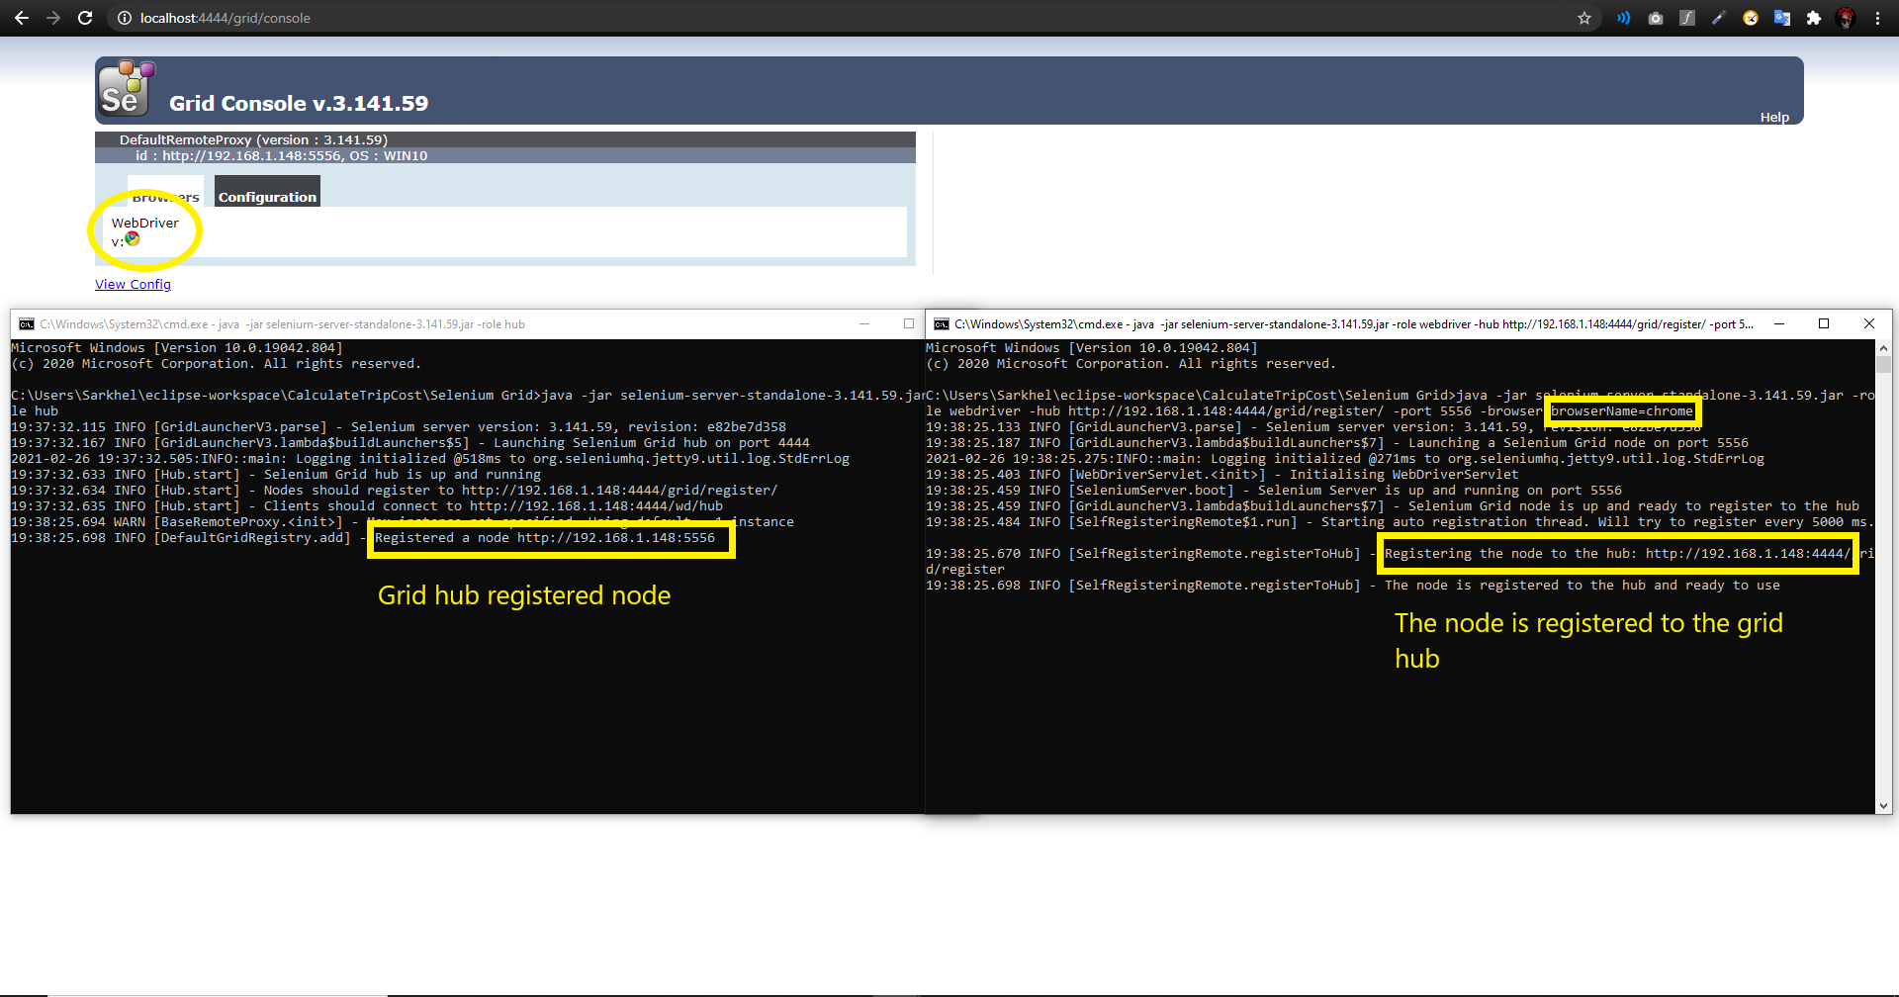

**GIT Implementation:**

**Link:** [**https://github.com/ArjunPrasadSarkhel/Hackathon_Calculate_Trip_Cost.git**](https://github.com/deysaheli009/Hackathon_2020/tree/master)

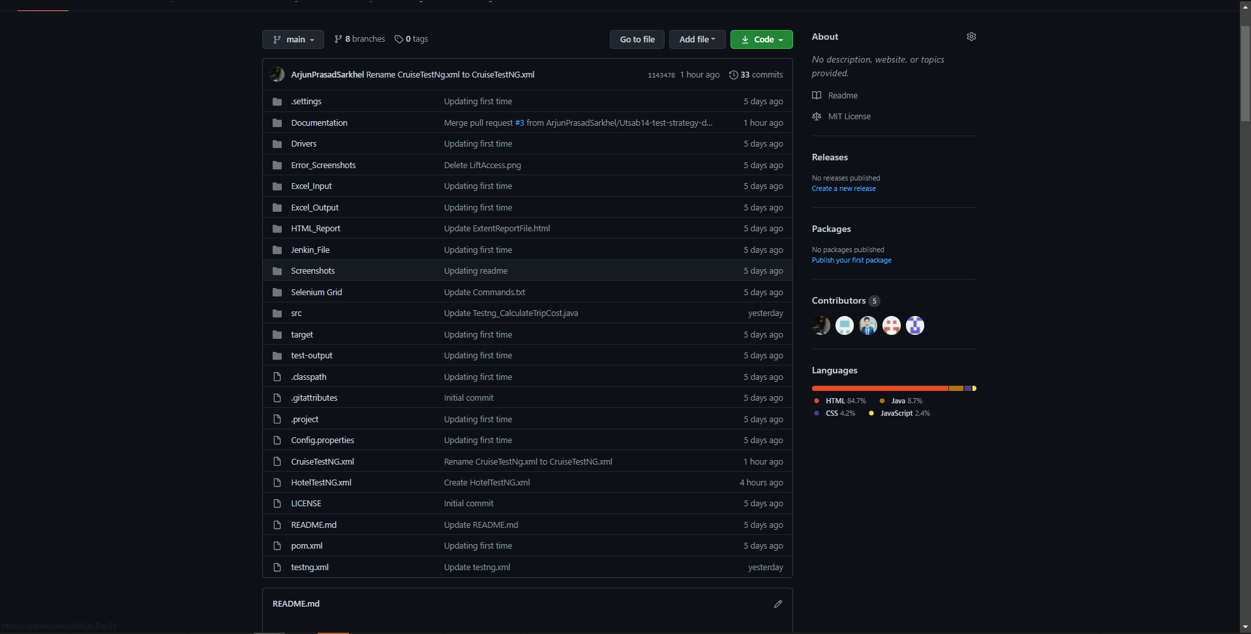

**Submitted By:**

## Arjun Prasad Sarkhel(888500)

## Jaydev Tonde(888249)

## Utsab Das(888488)

**Soujanya Bhat(888206)**

**Abhijit Das(888533)**